LAB PROGRAMS
CSA1015-SOFTWARE ENGINEERING
Question 12
You are designing a Task Management System for a small team. The
system should include the following features:
1. User Login and Role Assignment
2. Task Creation and Assignment
3. Task Prioritization and eadlines
4. Progress Tracking and Reporting
Prioritize these requirements using the MoSCoW and Kano models in
Jira. Step 1: Log in to jira account and create a new space from left side panel and select Scrum template
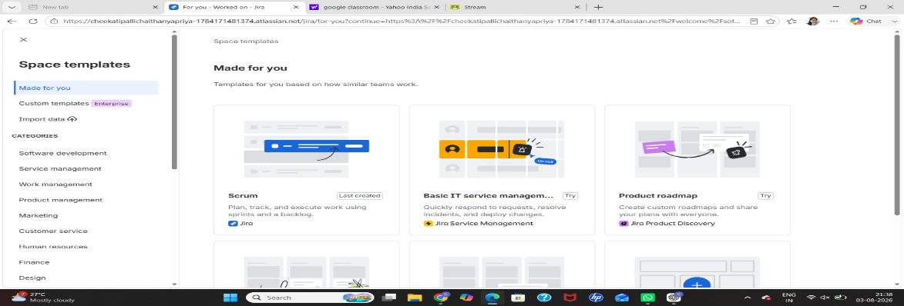
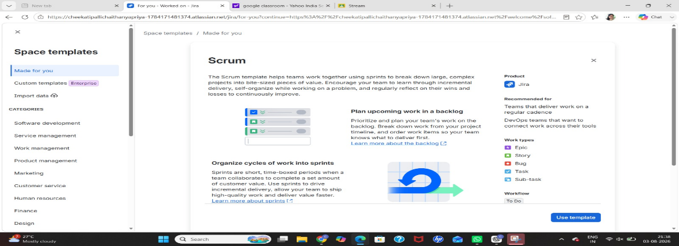
Step 2: Give the name of project
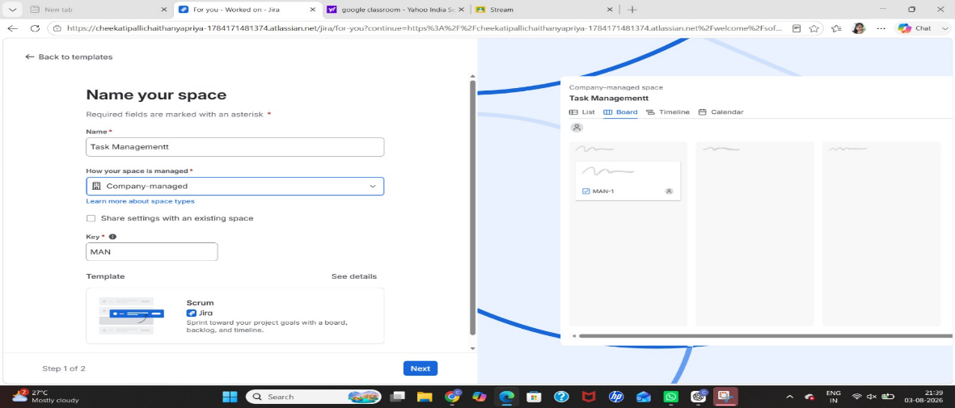
Step 3: Create the tasks in list and assign to team and date of task and priority level
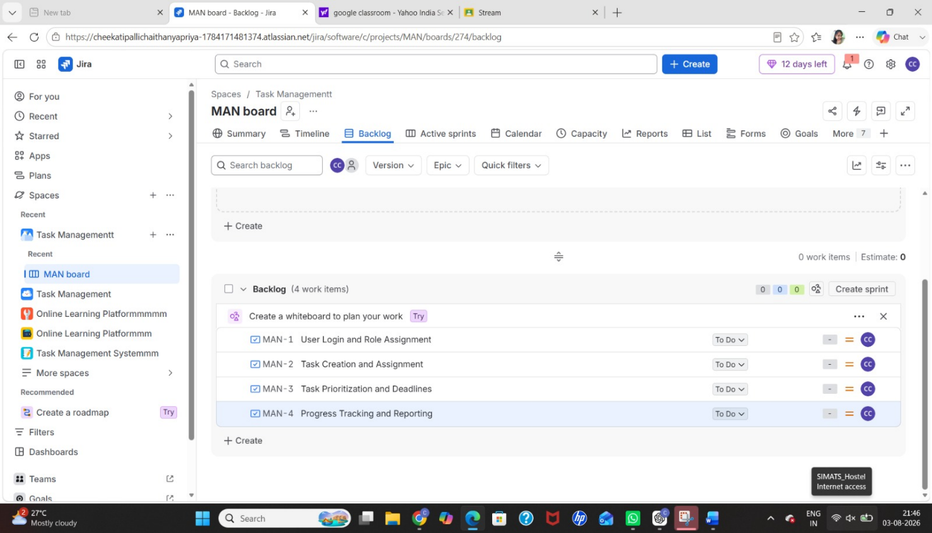
Step 4:Select priority level
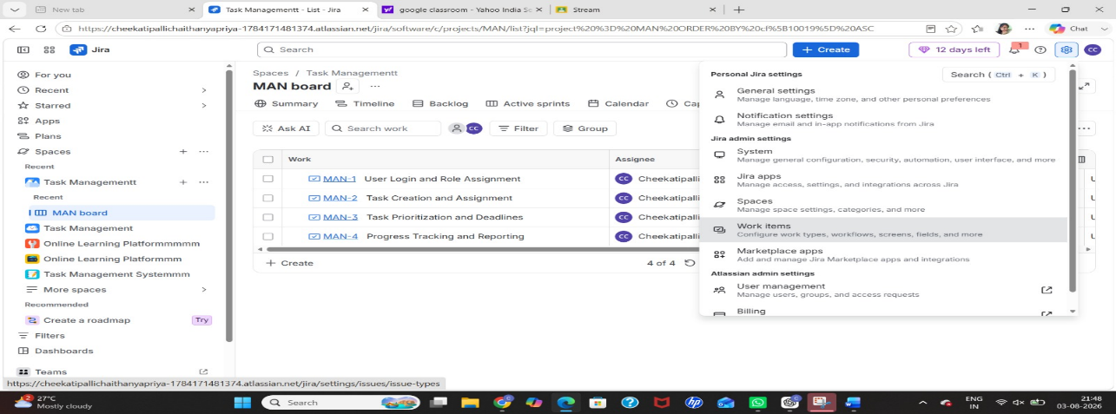
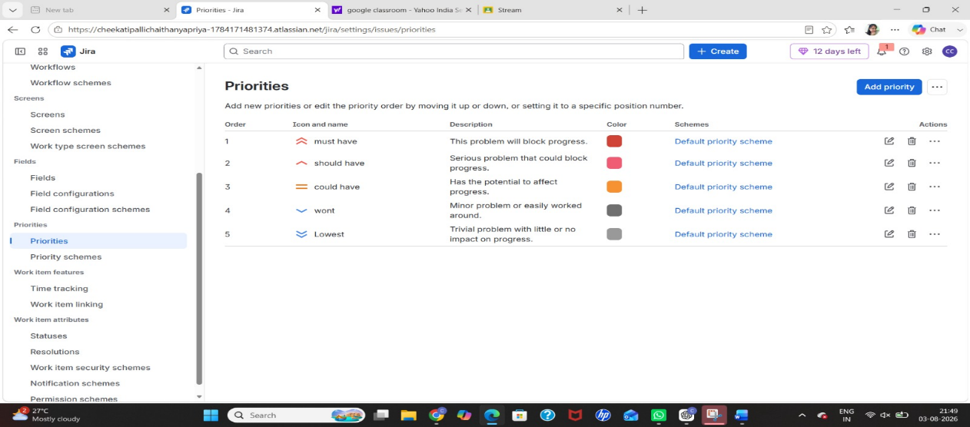

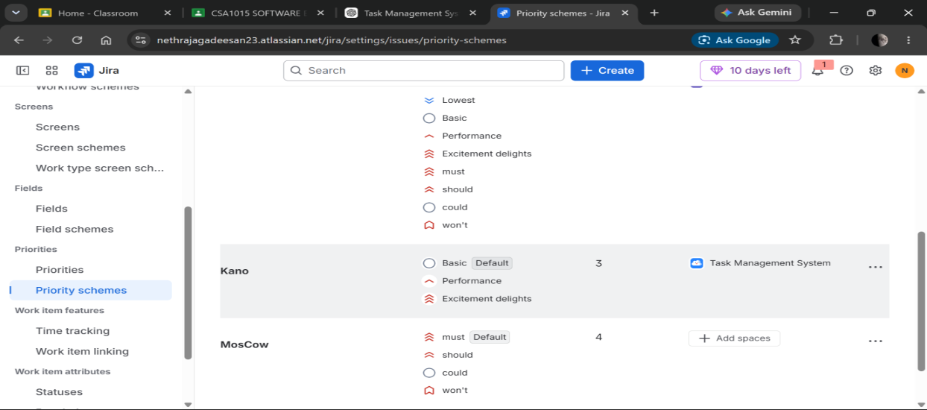

Step 5:Apply MosCow prioritization

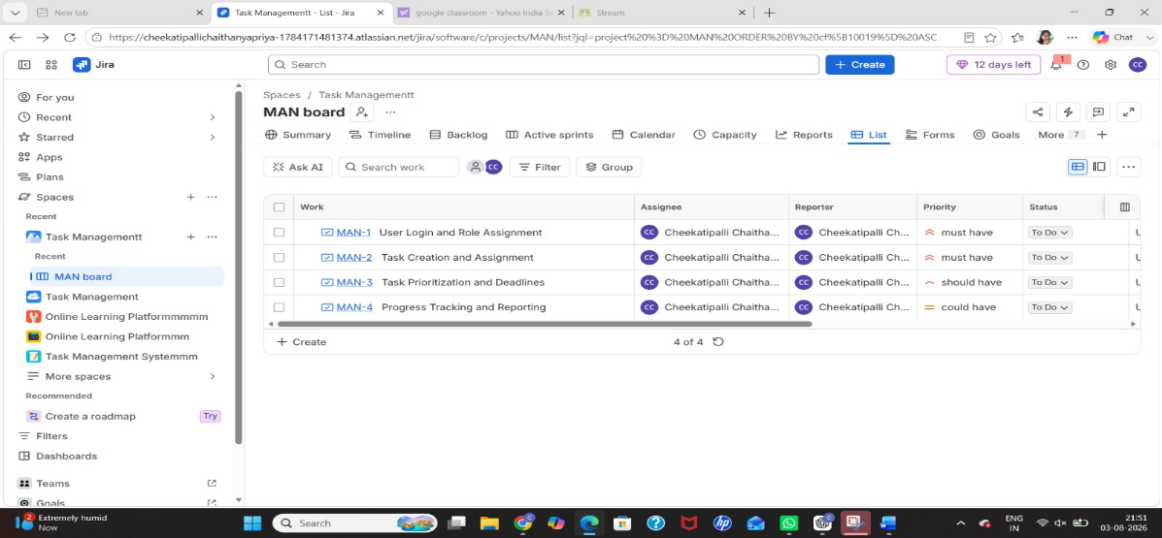

Step 6:We kano prioritization
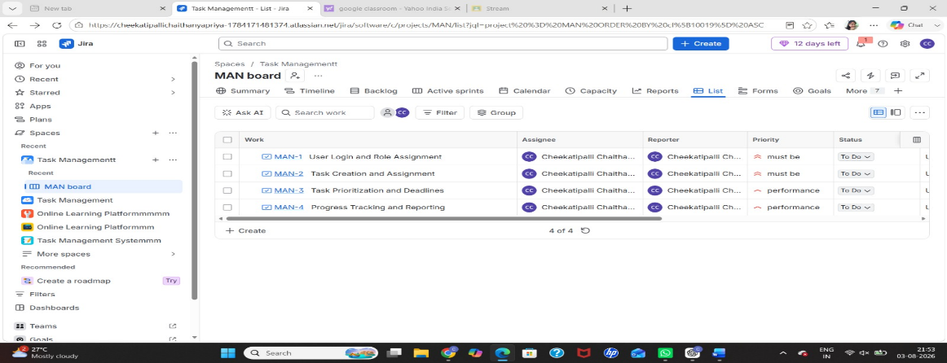
Step 7: We can see the summary in summary option
